Vanier College

Computer Science

Jake’s Café



Yassine El Yamani

Fiacre Byiringiro

Douyon Sebastiampillai

Table of Contents

Summary:

Menu page: 3

Order page: 4

The Menu 5

Drink’s Menu 6

CartForm: 7

Client’s information: 7

About us: 9

Application development project Report

# Menu page:

In our project, we created a menu for the Jake’s café where every client will have an option of ordering food, beverages and meals depending.

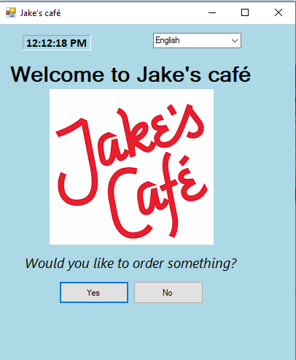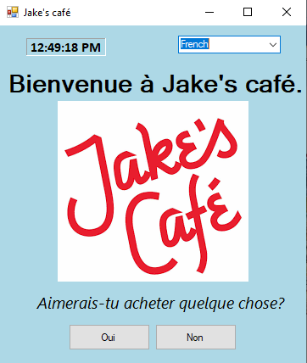

* The second screenshot is for internationalization which will change our form to a language the client will choose. We have three languages which are: **French, English, Arabic.**

# Order page:

In the order page, a student will order meals depending on the time of the day.

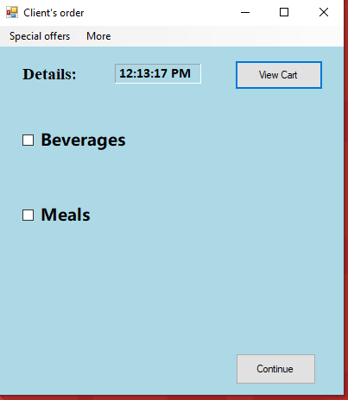

When the beverage and meals checked, they show all the available options you can choose:

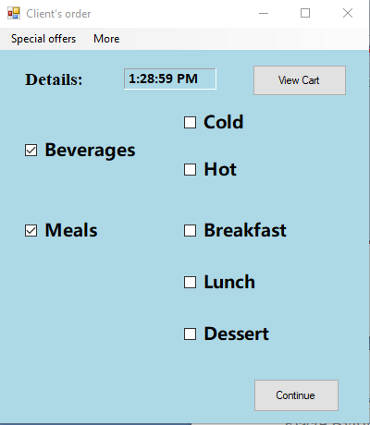

. For example, if it past 12:00PM, it will display “breakfast time is over”.

# The Menu

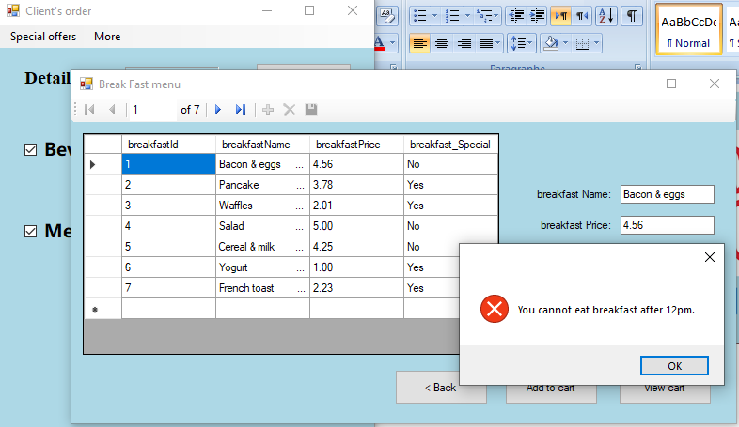

A messageBox is displayed when the breakfast checkbox is checked after (>=) 12 pm. If you press ok, the breakfast form is closed and you can see all the items that you can buy for next time.

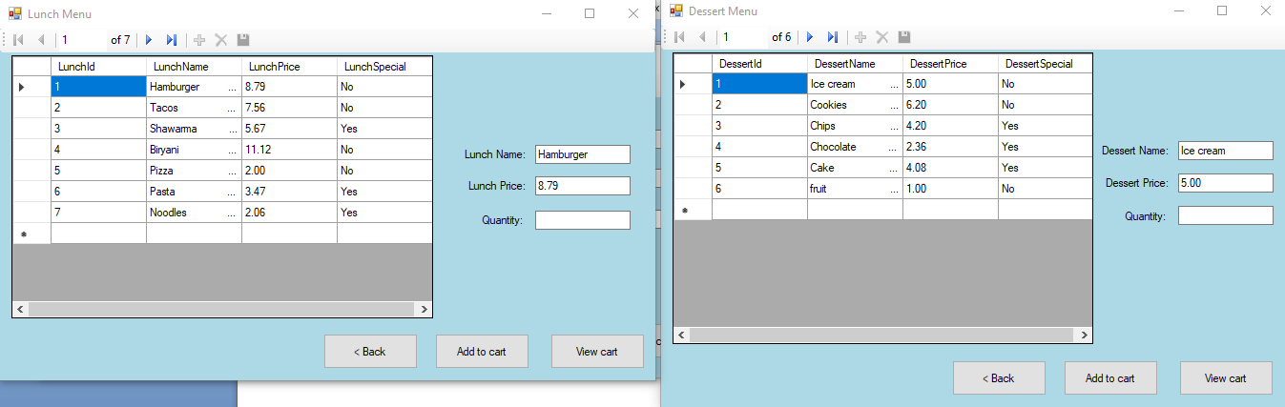

# Drink’s Menu

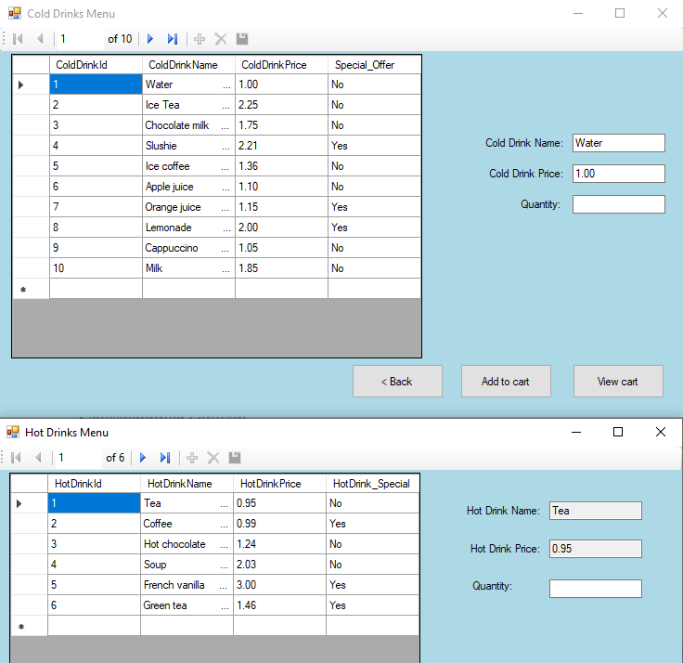

When the lunch, dessert, cold and hot checkboxes are checked, the following menus appear.

# CartForm:

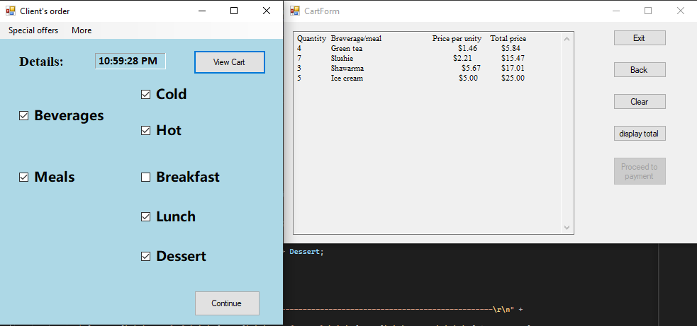

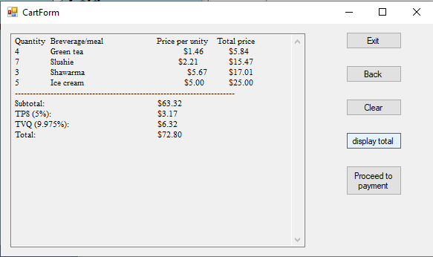

The form at the right is the CartForm and it has 5 buttons which are exit, back, clear, display total and proceed to payment. For the exit button, when it’s pressed the application stops running. For the back button, it’s to go back to the orderForm which is the previous form and if you press it takes you back to the orderForm. For the clear button, when it’s pressed it clears the textbox. For the display button, when it’s pressed it displays the addition of the total price, but if the cart is empty it wouldn’t display anything. We faced a problem in the calculation sometimes it works and sometimes it doesn’t. For the proceed to payment, when the cartForm is loaded the button is disabled until the cart is not empty anymore and the display total button is pressed. Once the proceed to payment button is pressed, it takes you to:

# Client’s information:

Once you decided what you want, it will show what you ordered and once you press “display total” it will give the subtotal price then taxes will be added to it and once that’s done, it will display the final total after the taxes. If you press “proceed to payment”, it will take you to another form to input all your payment information (Ex: Card number, name, Address, etc).

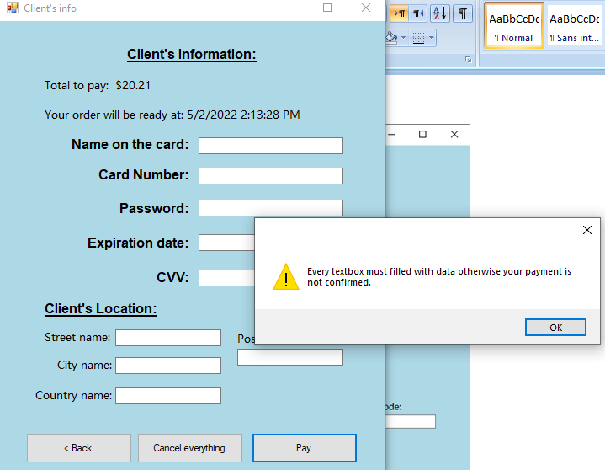

When payment information form appear, it require you to fill every textbox in order to get a successful payment or else it will tell you fill the missing textbox.

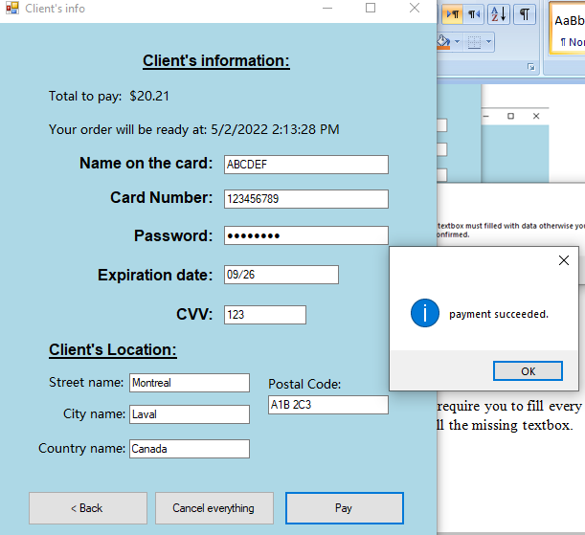

Once all the information is filled out, it will display payment succeeded and Exit the application.

*In the textbox “country name”, if you input another country beside Canada, it will display an error message showing that deliveries are only made in Canada.

*at the top of the page, it will display the total again in case the client forgot.

*at the top of the page, it displays the time when the order will be ready to ship. The order will always be ready 30 minutes after proceeding to payment.

*In case you want to cancel your order, there is an option too.

# About us:

We also created the about page that describe the time and the location of the Jake’s café. This additional information will be provided to every client in case they want to comeback to our café.

